Capstone Project

**Course code:** CSA4392

**Course:** Internet Programming for green tech

**Name:**

1. K. Manjunath Naidu

2.O. Mahesh Kumar

**Registration no:**

192211469

192211368

**Slot:** B

**Title:** Pet Adoption using HTML, JavaScript and php

**Guided by:** Venkatesan sir

**Department:** CSE

**College:** Saveetha School of Engineering



**Objectives**

1. **Develop a User-Friendly Interface:**
   * Create a responsive and intuitive front-end using HTML and CSS.
   * Ensure that users can easily navigate through the website and access different features such as viewing available pets, filtering by categories, and submitting adoption applications.
2. **Implement Dynamic Functionality with JavaScript:**
   * Use JavaScript to enhance user interaction by adding dynamic features like image sliders for pet galleries, form validation for adoption applications, and interactive search filters.
   * Provide real-time feedback to users, such as form errors or success messages.
3. **Build a Robust Back-End with PHP:**
   * Develop server-side scripts in PHP to handle form submissions, process adoption applications, and manage user data.
   * Use PHP for server-side validation, session management, and interactions with the database.
4. **Database Management with MySQL:**
   * Design a relational database in MySQL to store information about pets, adopters, and adoption applications.
   * Implement CRUD (Create, Read, Update, Delete) operations to manage data effectively.
5. **Ensure Data Security and Validation:**
   * Implement measures to protect sensitive information by securing form inputs, using prepared statements in SQL queries, and managing user sessions securely.
   * Validate user input both on the client-side (JavaScript) and server-side (PHP) to ensure data integrity and prevent security vulnerabilities like SQL injection.
6. **Facilitate Admin and User Roles:**
   * Create distinct interfaces and functionalities for admin users and regular users.
   * Allow admins to add, update, or remove pets from the adoption list, manage user accounts, and review adoption applications.
7. **Provide Responsive and Accessible Design:**
   * Ensure the platform is accessible across various devices by implementing responsive design principles.
   * Adhere to web accessibility standards to make the platform usable for people with disabilities.
8. **Integrate External APIs and Services:**
   * Utilize APIs for additional features such as location-based pet searches or integration with social media for sharing adoptable pets.
   * Include features like email notifications for adoption updates or reminders.

**Keywords**

* Pet Adoption
* Web Development
* HTML
* JavaScript
* PHP
* MySQL
* User Interface (UI)
* User Experience (UX)
* Responsive Design
* Form Handling
* Database Management
* Server-Side Scripting
* Client-Side Scripting
* API Integration
* Web Application
* **Introduction**

Pet adoption platforms are crucial in connecting rescue animals with loving homes. These platforms streamline the adoption process by allowing potential pet owners to view available pets, gather information, and apply for adoption online. Our project aims to create a web-based pet adoption system using HTML, JavaScript, and PHP to facilitate this process. The system will feature a user-friendly interface, real-time interaction, and a robust back-end to handle data management and adoption applications.

This project aims to create an interactive and efficient system that connects potential pet adopters with animals in need of homes. By leveraging modern web technologies, our platform will provide users with an intuitive and engaging experience, allowing them to browse available pets, filter searches by various criteria, view detailed profiles, and submit adoption applications online.

HTML (Hypertext Markup Language) will form the backbone of the website, providing structure and content. JavaScript will enhance the user experience by adding dynamic interactions and real-time features, such as instant form validation and interactive pet galleries. PHP (Hypertext Preprocessor) will be employed for server-side scripting, managing data interactions, processing user inputs, and communicating with a MySQL database to handle the backend operations.

Our platform aims to modernize the pet adoption process by bridging the gap between prospective pet owners and animals in need of homes. With a dedicated backend for managing pet data and adoption applications, administrators can efficiently oversee listings and applications. Meanwhile, the user-centric design will empower adopters to find their ideal pets with ease. By integrating best practices in web development and focusing on usability, we aspire to enhance the adoption experience, promote animal welfare, and connect more pets with loving homes.

* **Pets Adoption (HTML):**

<!DOCTYPE html>

<html lang="en">

<head>

  <meta charset="UTF-8">

  <meta name="viewport" content="width=device-width, initial-scale=1.0">

  <title>View Pets</title>

  <link rel="stylesheet" href="styles.css">

</head>

<body>

  <header>

    <h1>Pet Adoption</h1>

    <nav>

      <ul>

        <li><a href="index.html">Home</a></li>

        <li><a href="pets.html">View Pets</a></li>

        <li><a href="contact.html">Contact</a></li>

      </ul>

    </nav>

  </header>

  <div id="pets-container">

    <!-- Pets will be dynamically added here -->

    <h1>pets</h1>

  </div>

  <footer>

    <p>&copy; 2024 Pet Adoption</p>

  </footer>

  <script src="script.js"></script>

</body>

</html>

* **OUTPUT:**

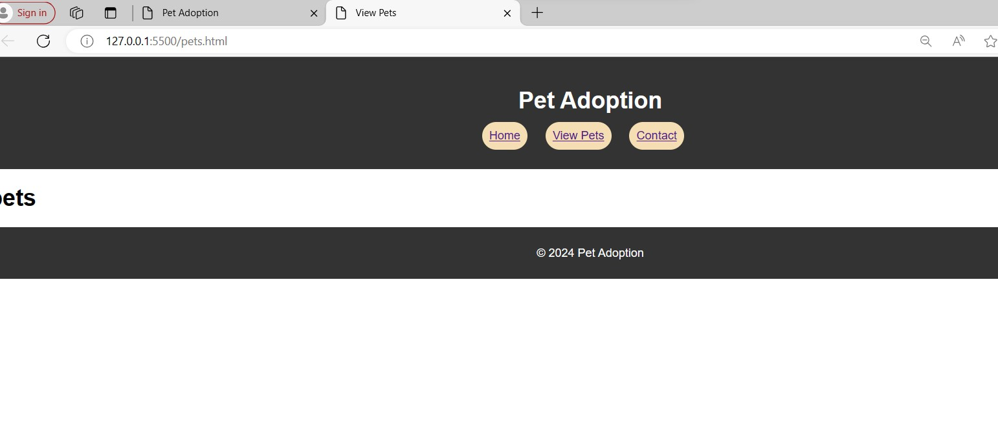

* **PET ADOPTION WEBSITE**

<!DOCTYPE html>

<html lang="en">

<head>

  <meta charset="UTF-8">

  <meta name="viewport" content="width=device-width, initial-scale=1.0">

  <title>Pet Adoption</title>

  <link rel="stylesheet" href="styles.css">

</head>

<body>

  <header>

    <h1>Pet Adoption</h1>

    <nav>

      <ul>

        <li><a href="index.html">Home</a></li>

        <li><a href="pets.html">View Pets</a></li>

        <li><a href="contact.html">Contact</a></li>

      </ul>

    </nav>

  </header>

  <div class="hero">

    <img src="cat.jpeg" alt="Pet Adoption" class="hero-image">

    <img src="pet1.jpeg" alt="Pet Adoption" class="hero-image">

    <h2>Welcome to our Pet Adoption Website</h2>

    <p>Find your new furry friend today!</p>

  </div>

  <footer>

    <p>&copy; 2024 Pet Adoption</p>

  </footer>

</body>

</html>

* **OUTPUT:**

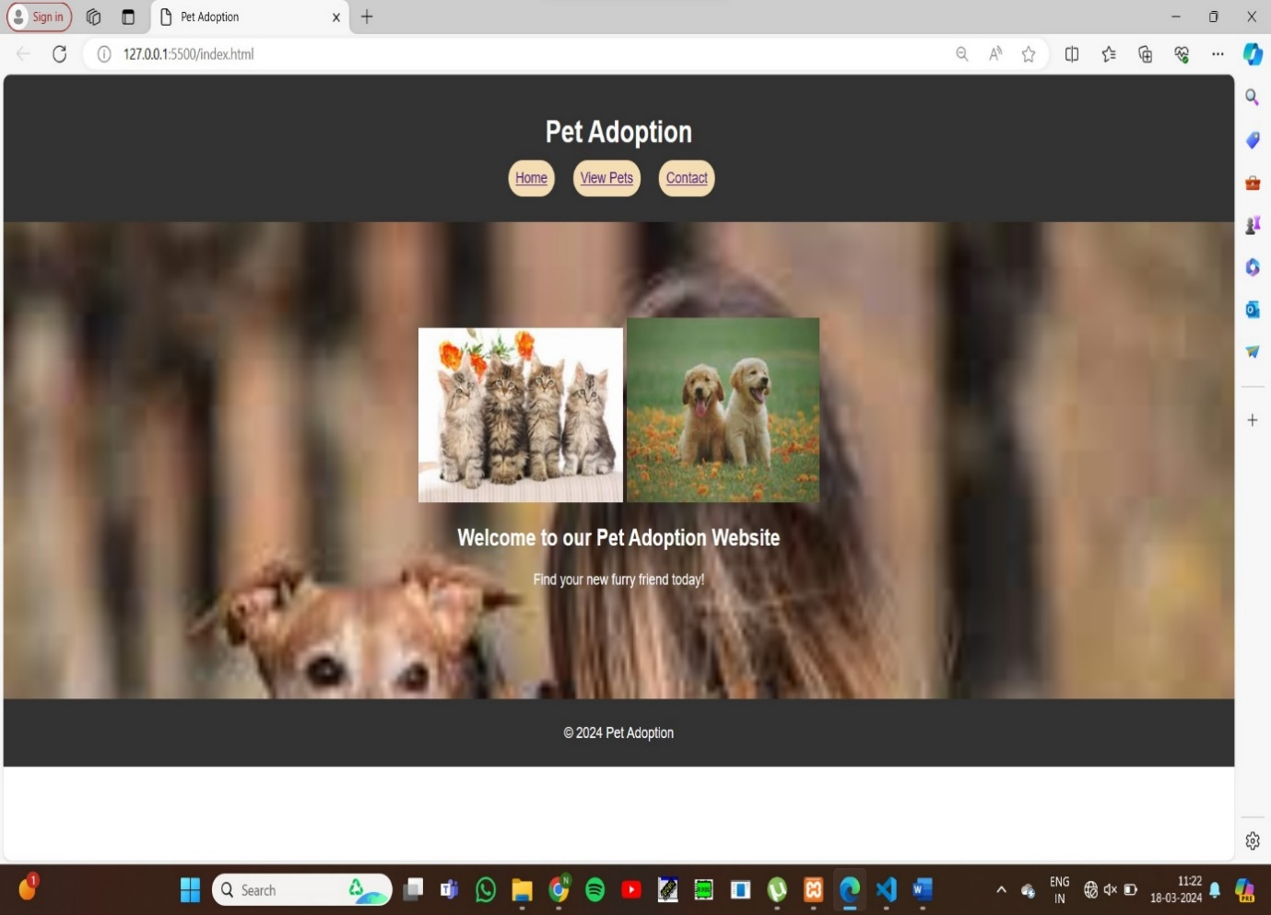

* **CONTACT HTML:**

<!DOCTYPE html>

<html>

<head>

    <title>Registration Form</title>

</head>

<body>

    <center>

    <h2>Registration Form</h2>

    <form method="post" action="<?php echo htmlspecialchars($_SERVER["PHP_SELF"]); ?>">

        <input type="hidden" name="action" value="submit_registration">

        <label for="firstname">First Name:</label><br>

        <input type="text" id="firstname" name="firstname"><br><br>

        <label for="lastname">Last Name:</label><br>

        <input type="text" id="lastname" name="lastname"><br><br>

        <label for="phonenumber">Phone Number:</label><br>

        <input type="text" id="phonenumber" name="phonenumber"><br><br>

        <label for="username">Username:</label><br>

        <input type="text" id="username" name="username"><br><br>

        <label for="email">Email:</label><br>

        <input type="email" id="email" name="email"><br><br>

        <label for="password">Password:</label><br>

        <input type="password" id="password" name="password"><br><br>

        <label for="gender">Gender:</label><br>

        <select id="gender" name="gender">

            <option value="male">Male</option>

            <option value="female">Female</option>

            <option value="other">Other</option>

        </select><br><br>

        <input type="submit" value="Submit">

    </form>

    </center>

* **OUTPUT:**

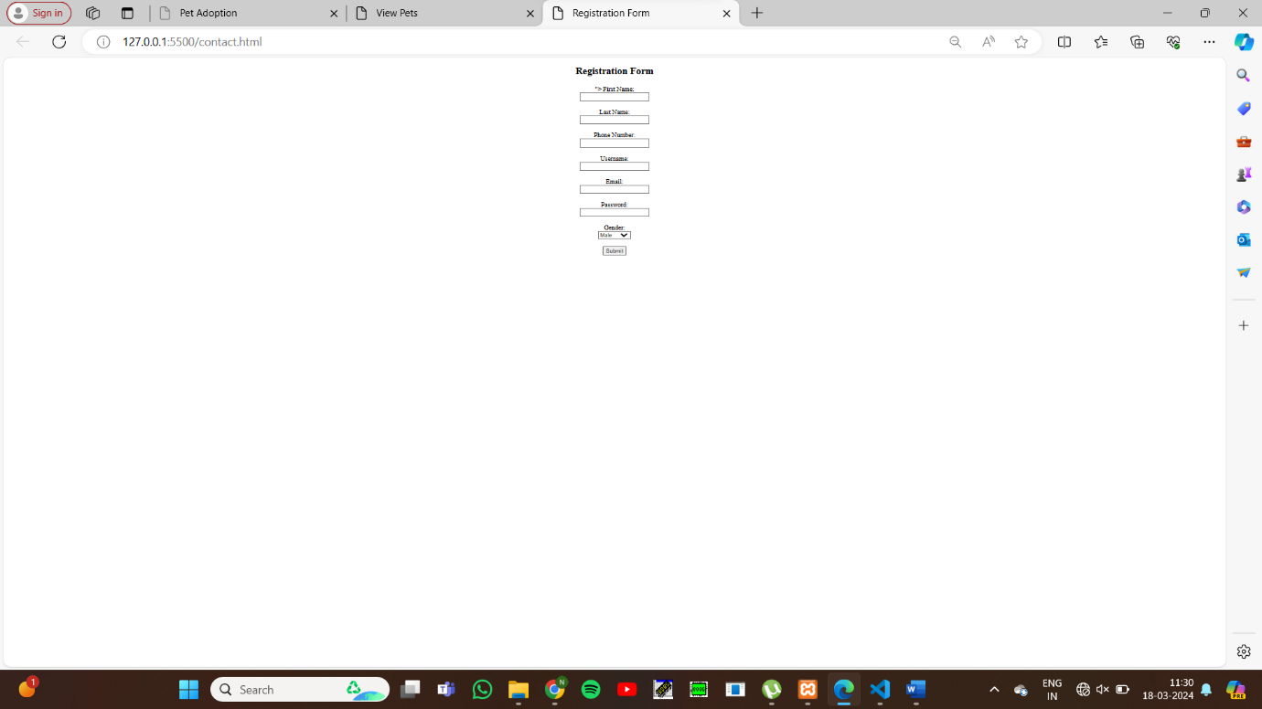

* **PHP DATA BASE CODE:**

<!DOCTYPE html>

<html>

<head>

    <title>Registration Form</title>

</head>

<body>

    <center>

    <h2>Registration Form</h2>

    <form method="post" action="<?php echo htmlspecialchars($_SERVER["PHP_SELF"]); ?>">

        <input type="hidden" name="action" value="submit_registration">

        <label for="firstname">First Name:</label><br>

        <input type="text" id="firstname" name="firstname"><br><br>

        <label for="lastname">Last Name:</label><br>

        <input type="text" id="lastname" name="lastname"><br><br>

        <label for="phonenumber">Phone Number:</label><br>

        <input type="text" id="phonenumber" name="phonenumber"><br><br>

        <label for="username">Username:</label><br>

        <input type="text" id="username" name="username"><br><br>

        <label for="email">Email:</label><br>

        <input type="email" id="email" name="email"><br><br>

        <label for="password">Password:</label><br>

        <input type="password" id="password" name="password"><br><br>

        <label for="gender">Gender:</label><br>

        <select id="gender" name="gender">

            <option value="male">Male</option>

            <option value="female">Female</option>

            <option value="other">Other</option>

        </select><br><br>

        <input type="submit" value="Submit">

    </form>

    </center>

    <?php

    $servername = "localhost";

    $username = "root";

    $password = "";

    $dbname = "pet";

    $conn = new mysqli($servername, $username, $password, $dbname);

    if ($conn->connect_error) {

        die("Connection failed: " . $conn->connect_error);

    }

    if (isset($_POST['action']) && $_POST['action'] == 'submit_registration') {

        $firstname = isset($_POST['firstname']) ? $conn->real_escape_string($_POST['firstname']) : '';

        $lastname = isset($_POST['lastname']) ? $conn->real_escape_string($_POST['lastname']) : '';

        $phonenumber = isset($_POST['phonenumber']) ? $conn->real_escape_string($_POST['phonenumber']) : '';

        $username = isset($_POST['username']) ? $conn->real_escape_string($_POST['username']) : '';

        $email = isset($_POST['email']) ? $conn->real_escape_string($_POST['email']) : '';

        $password = isset($_POST['password']) ? $conn->real_escape_string($_POST['password']) : '';

        $gender = isset($_POST['gender']) ? $conn->real_escape_string($_POST['gender']) : '';

        $sql = "INSERT INTO details(firstname, lastname, phonenumber, username, email, password, gender)

                VALUES ('$firstname', '$lastname', '$phonenumber', '$username', '$email', '$password', '$gender')";

        if ($conn->query($sql) === TRUE) {

            echo "Records inserted successfully.";

        } else {

            echo "ERROR: Could not able to execute $sql. " . $conn->error;

        }

    }

    $conn->close();

    ?>

</body>

</html>

* **OUTPUT:**

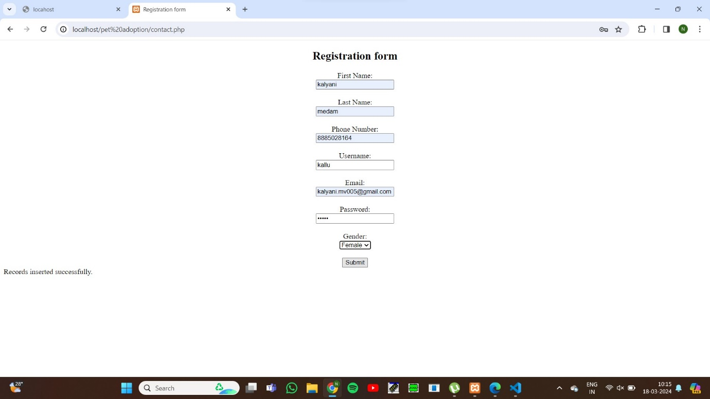

* **STYLE SHEET CSS:**

body {

    font-family: Arial, sans-serif;

    margin: 0;

    padding: 0;

  }

  header {

    background-color: #333;

    color: white;

    padding: 20px;

    text-align: center;

  }

  nav ul {

    list-style-type: none;

    padding: 0;

  }

  nav ul li {

    display: inline;

    margin-right: 20px;

    background-color:wheat;

    padding: 10px;

    border-radius: 20px;

    text-decoration-color: black;

  }

  .hero {

    background-image: url('background.jpeg');

    background-size: cover;

    color: white;

    text-align: center;

    padding: 100px 0;

  }

  footer {

    background-color: #333;

    color: white;

    padding: 10px 0;

    text-align: center;

  }

  .contact-form {

    margin: 20px auto;

    width: 50%;

  }

  .contact-form form {

    border: 1px solid #ccc;

    padding: 20px;

  }

  .contact-form label {

    display: block;

    margin-bottom: 5px;

  }

  .contact-form input[type="text"],

  .contact-form input[type="email"],

  .contact-form textarea {

    width: 100%;

    margin-bottom: 10px;

  }

  .contact-form button {

    background-color: #333;

    color: white;

    border: none;

    padding: 10px 20px;

    cursor: pointer;

  }

  .contact-form button:hover {

    background-color: #555;

  }

* **OUTPUT:**



* **CONCLUSION:**
* By leveraging HTML, JavaScript, and PHP, this pet adoption project aims to build a comprehensive and user-friendly web application that simplifies the process of finding and adopting pets. Through robust features and efficient data management, the platform will enhance the adoption experience for users and facilitate the process of providing homes for pets in need.